office workspace design
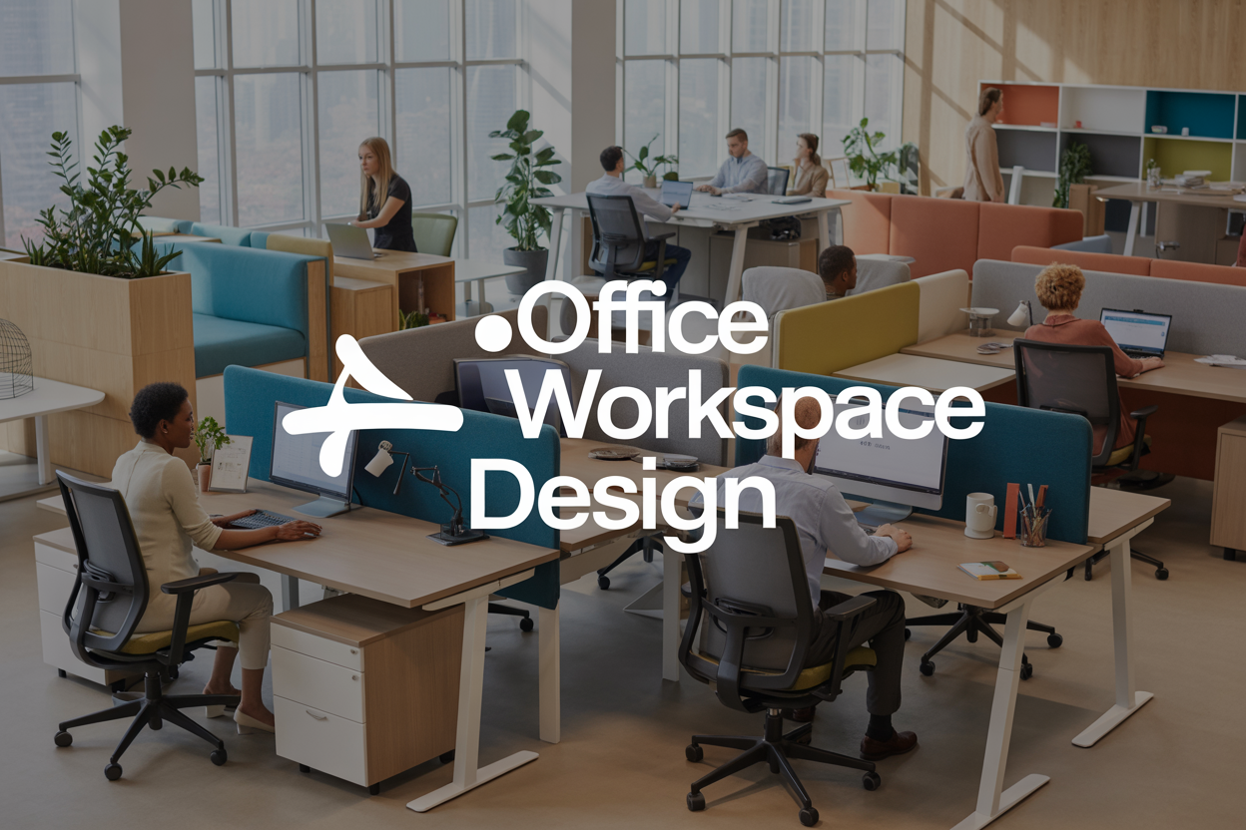
Your office workspace design directly impacts how your team feels, performs, and collaborates every single day. For business owners, office managers, and HR professionals looking to boost productivity and employee satisfaction, the right design choices can transform your workplace from a basic room into a powerhouse of innovation and efficiency.
Getting your office space planning right isn't just about fitting desks into a room. You'll discover how smart layouts maximize every square foot while creating natural flow patterns that actually help people work better. We'll also explore how color psychology and ergonomic office furniture work together to reduce stress, prevent injuries, and keep your team energized throughout the day.
Ready to turn your office into a space people actually want to work in? Let's dive into the essential elements that make productive office design really work.

Essential Elements for Productive Office Design
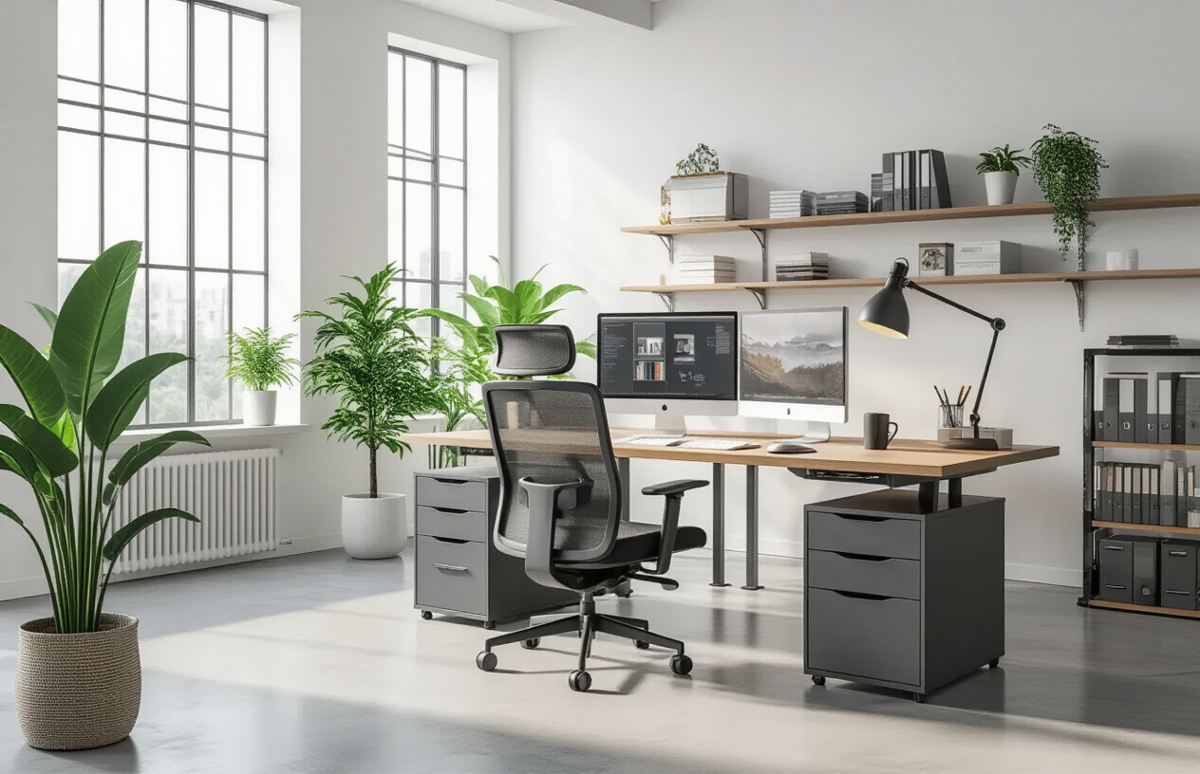

Optimize natural lighting to boost employee energy and focus
Natural light transforms office spaces in ways that artificial lighting simply can't match. When employees work in environments flooded with daylight, their circadian rhythms stay balanced, leading to better sleep patterns and higher energy levels throughout the workday. This biological advantage translates directly into improved focus and productivity. Smart office workspace design positions workstations near windows whenever possible, while using glass partitions and open layouts to distribute light deeper into the space.
The key is controlling harsh glare while maximizing brightness. Adjustable blinds, light shelves, and strategically placed reflective surfaces help bounce natural light into darker corners without creating uncomfortable conditions. Skylights work wonders in interior spaces where traditional windows aren't feasible. When natural light is limited, full-spectrum LED lighting systems can mimic daylight patterns, gradually shifting color temperature throughout the day to support natural energy cycles.

Create flexible seating arrangements for different work styles
Modern productive office design recognizes that people work differently and need various settings to perform their best. Fixed desk arrangements belong in the past - today's successful workspaces offer multiple seating options that employees can choose based on their current tasks and personal preferences. Some workers thrive in open, collaborative areas with comfortable lounge seating, while others need quiet, focused zones with traditional desk setups.
Activity-based working zones give employees the freedom to move between different environments as their work demands change. Quiet pods with high-backed chairs support deep concentration work, while standing desks and bar-height tables encourage movement and energy. Soft seating areas with ottomans and bean bags create casual meeting spots that feel less formal than conference rooms. The magic happens when these different zones flow naturally together, allowing workers to seamlessly transition between collaboration and focused individual work without feeling confined to a single assigned spot.

Integrate technology seamlessly for enhanced workflow efficiency
Technology integration should feel invisible in well-designed office spaces. Cables, adapters, and charging stations need strategic placement so they're accessible without creating visual clutter or tripping hazards. Built-in USB ports, wireless charging surfaces, and pop-up power outlets in conference tables eliminate the scramble for connections during meetings. Digital displays replace traditional whiteboards in collaboration areas, allowing teams to share screens instantly and save their work digitally.
Smart office systems connect lighting, temperature, and security controls through intuitive interfaces that employees can adjust from their phones or tablets. Video conferencing equipment becomes part of the room's design rather than an awkward add-on, with cameras and microphones positioned for optimal audio and visual quality. The goal is creating spaces where technology enhances human interaction rather than complicating it, supporting both in-person and remote collaboration without technical barriers getting in the way.

Design noise management solutions for better concentration
Sound control makes the difference between a chaotic workspace and a productive environment where people can actually think. Open office layouts require careful acoustic planning to prevent conversations, phone calls, and equipment noise from disrupting concentration. Sound-absorbing materials like acoustic panels, carpeting, and fabric-covered furniture help reduce noise levels without making spaces feel sterile or institutional.
Creating natural sound barriers through strategic placement of bookshelves, plants, and partition walls helps contain noise where it starts. White noise from HVAC systems or dedicated sound masking technology can cover distracting intermittent sounds without being noticeable itself. Different zones need different acoustic treatments - collaborative areas can handle higher noise levels while focus zones require maximum sound control. Phone booths and small meeting rooms give people private spaces for calls and video conferences, preventing these necessary activities from disrupting others' work.

Space Planning Strategies That Maximize Functionality
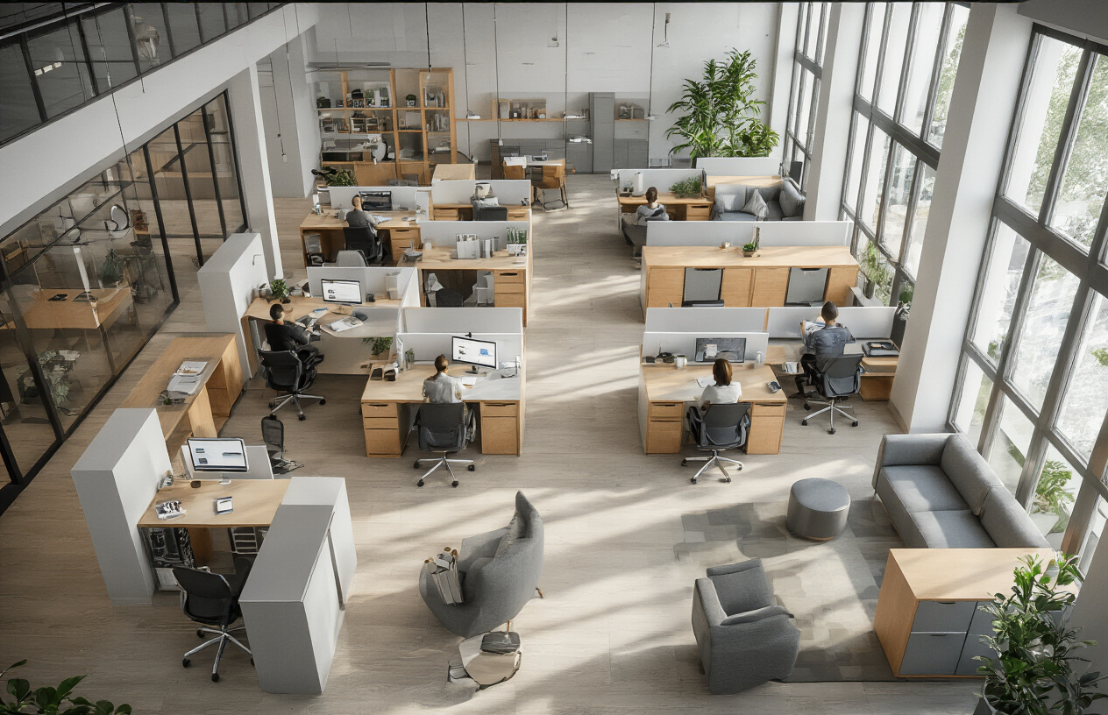

Balance open areas with private workspaces effectively
Creating the perfect balance between open collaboration zones and quiet private spaces is like orchestrating a workplace symphony. The key lies in understanding that different tasks require different environments. Open areas work beautifully for brainstorming sessions, casual meetings, and fostering team connections, while private workspaces provide the focus needed for deep work, confidential calls, and detailed analysis.
The 70-20-10 rule serves as an excellent starting point for office space planning. Dedicate 70% of your space to collaborative open areas, 20% to semi-private zones like phone booths or small meeting rooms, and 10% to fully private offices. This ratio supports both teamwork and individual productivity without sacrificing either.
Consider implementing flexible boundaries using moveable partitions, sliding glass panels, or even strategically placed furniture. These solutions allow spaces to transform based on daily needs while maintaining visual connections across the office. Height variations also play a crucial role – low partitions preserve the open feel while providing acoustic separation.

Implement smart storage solutions to reduce clutter
Clutter kills productivity faster than almost anything else in workplace design ideas. Smart storage goes beyond traditional filing cabinets to include built-in solutions that keep supplies organized and surfaces clear. Wall-mounted storage systems maximize vertical space while keeping frequently used items within easy reach.
Digital storage integration reduces the need for physical filing systems. Create designated charging stations with cord management systems to eliminate desktop cable chaos. Under-desk storage pedestals serve double duty as footrests and filing systems, while overhead storage keeps seasonal or rarely used items accessible but out of sight.
Activity-based storage works particularly well in modern office layouts. Place storage solutions where specific tasks happen – printer supplies near printing stations, presentation materials in conference areas, and personal storage at individual workstations. This approach reduces unnecessary movement and keeps everything organized naturally.

Design traffic flow patterns that minimize disruptions
Traffic flow design directly impacts employee workspace optimization and overall office functionality. Main circulation paths should connect key destinations – entrances, elevators, restrooms, and break areas – without cutting through quiet work zones. Think of these pathways as highways that keep the heavy traffic away from residential neighborhoods.
The 48-inch rule for main corridors ensures comfortable two-way traffic, while secondary paths can narrow to 36 inches for single-file movement. Position high-traffic amenities like printers, coffee stations, and supply closets away from concentration zones to prevent constant interruptions.
Visual sight lines matter just as much as physical pathways. Clear views across the space help people navigate naturally while avoiding bottlenecks. Strategic placement of collaborative office spaces near natural gathering points like kitchens or reception areas encourages spontaneous interactions without disrupting focused work areas.
Consider the daily rhythms of your office when planning productive office design. Morning arrival patterns, lunch rush timing, and end-of-day departure flows all create predictable traffic surges that smart planning can accommodate smoothly.

Color Psychology and Material Choices for Enhanced Performance
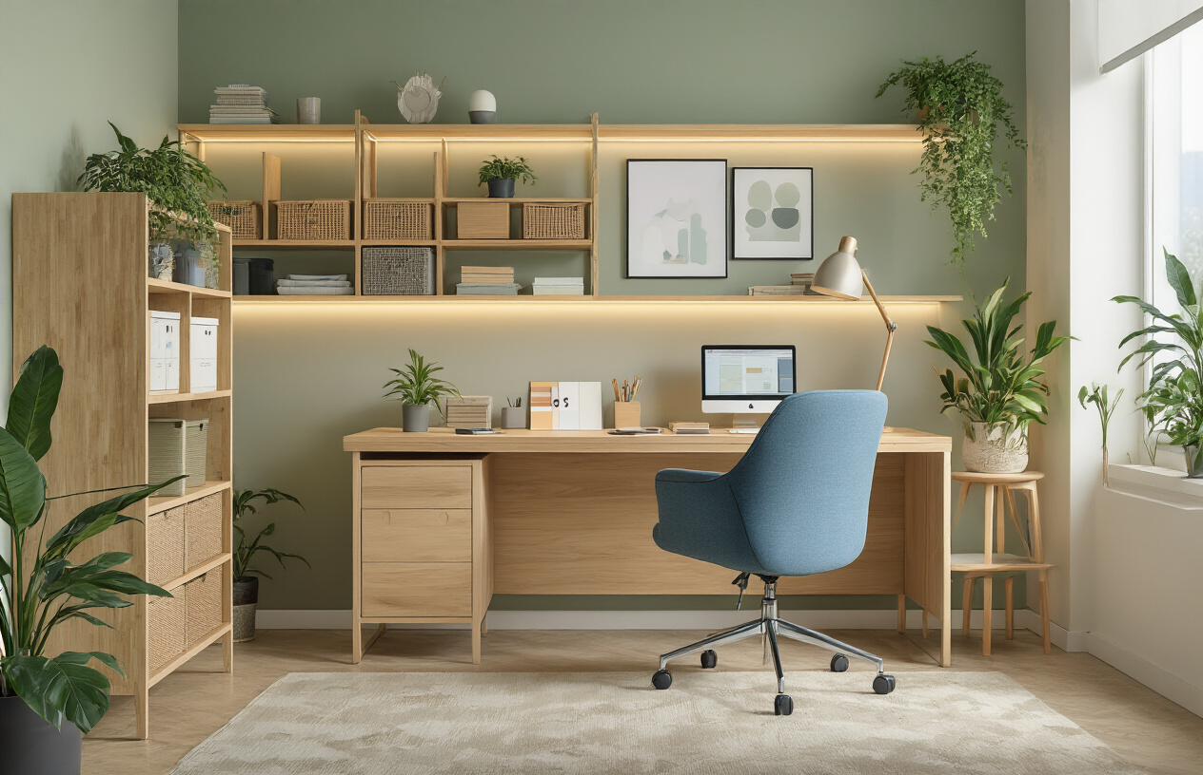

Select colors that promote creativity and reduce stress
Color choices dramatically impact employee mood, productivity, and stress levels in modern office layout environments. Blue tones increase focus and mental clarity, making them perfect for areas requiring deep concentration like analysis or financial work. Green promotes balance and reduces eye strain, particularly beneficial near computer workstations where employees spend extended periods. Warm yellows stimulate creativity and energy, ideal for brainstorming rooms and collaborative office spaces.
Red should be used sparingly as an accent color since it can increase anxiety and agitation when overused. Purple enhances innovation and problem-solving abilities, working well in design studios or creative departments. Neutral colors like warm grays and beiges create calming foundations that allow accent colors to shine without overwhelming the senses.
Consider the psychological effects when planning your office workspace design. Cool colors slow heart rate and promote calmness, while warm colors increase energy and social interaction. Natural lighting affects how colors appear throughout the day, so test paint samples under different lighting conditions before making final decisions.

Choose durable materials that withstand daily office use
High-traffic office environments demand materials that maintain their appearance and functionality over years of constant use. Commercial-grade carpet tiles offer excellent durability while allowing easy replacement of damaged sections. Luxury vinyl planks provide the warmth of wood flooring with superior resistance to scratches, dents, and moisture damage.
For wall surfaces, consider materials that resist scuffs and fingerprints while supporting productive office design goals. High-quality paint with semi-gloss or satin finishes wipes clean easily and maintains color integrity longer than flat finishes. Fabric-wrapped acoustic panels serve dual purposes by reducing noise while adding visual appeal to conference rooms and open workspaces.
Material Type | Durability Rating | Maintenance Level | Cost Range
Commercial Carpet | High | Medium | ₹120 – ₹300
Luxury Vinyl | Very High | Low | ₹180 – ₹450
Laminate Surfaces | High | Low | ₹90 – ₹250
Natural Stone | Very High | High | ₹350 – ₹1,200
Countertops and work surfaces see heavy daily use requiring materials like quartz, solid surface, or high-pressure laminate. These options resist stains, scratches, and heat while maintaining professional aesthetics that support employee workspace optimization.

Incorporate textures that add visual interest and comfort
Texture variety prevents office spaces from feeling sterile or monotonous while supporting workplace design ideas that prioritize employee satisfaction. Soft textures like upholstered seating, area rugs, and fabric wall panels create psychological warmth and acoustic comfort. These elements make spaces feel more residential and less institutional.
Natural textures bring organic elements indoors, reducing stress and connecting employees with nature. Wood grain surfaces, whether real or high-quality laminates, add warmth and visual interest to reception areas and conference rooms. Stone or brick accent walls create focal points while adding depth and character to otherwise plain surfaces.
Smooth surfaces like glass and polished metals reflect light and create modern, clean aesthetics essential to contemporary office interior design. Balance these with rougher textures like woven fabrics, textured wallpapers, or brushed metal finishes to prevent spaces from feeling cold or unwelcoming.
Mix textures strategically throughout different zones. Reception areas benefit from luxurious textures that impress visitors, while work zones need practical textures that support daily functions without requiring excessive maintenance.

Balance professional aesthetics with employee wellbeing
Creating environments that look professional while supporting mental and physical health requires thoughtful integration of design elements. Professional appearance doesn't mean sacrificing comfort or personality. Incorporate plants, artwork, and comfortable seating areas that maintain sophisticated aesthetics while boosting employee morale and creativity.
Natural elements like living walls or large planters improve air quality while softening hard architectural lines. These biophilic design elements reduce stress hormones and increase cognitive function without compromising the polished appearance clients expect.
Flexible spaces allow employees to choose environments that match their current tasks and energy levels. Quiet zones with soft textures and muted colors support focused work, while dynamic areas with energizing colors and varied seating options encourage collaboration and creative thinking.
Consider how different areas serve various stakeholders. Client-facing spaces need more formal aesthetics, while employee-only areas can embrace warmer, more casual design elements. This approach maintains professional standards where needed while prioritizing employee comfort and wellbeing in daily work environments.
Lighting plays a crucial role in balancing these objectives. Natural light improves mood and productivity while reducing the harsh institutional feeling of traditional fluorescent lighting. Supplement with warm LED fixtures that create inviting atmospheres without sacrificing the clean, professional appearance modern businesses require.

Ergonomic Furniture Solutions for Employee Health
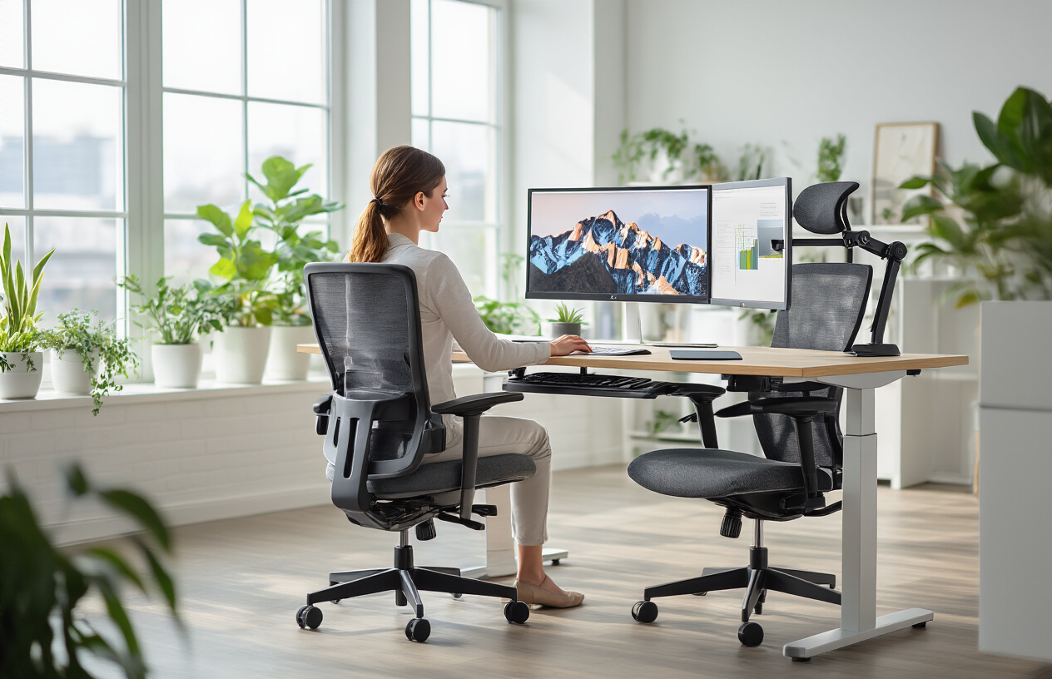

Invest in Adjustable Desks to Support Various Working Positions
Adjustable desks are game-changers in modern office workspace design, offering employees the flexibility to alternate between sitting and standing throughout their workday. These versatile pieces of ergonomic office furniture combat the health risks associated with prolonged sitting while boosting energy and productivity levels.
Height-adjustable desks come in various configurations, from electric motorized options that adjust smoothly at the touch of a button to manual crank models that offer budget-friendly alternatives. When selecting adjustable desks for your workplace design ideas, consider desks with memory presets that allow users to save their preferred sitting and standing heights for quick transitions.
The benefits extend beyond physical health. Employees report increased alertness and improved focus when they can change positions throughout the day. Standing meetings become more natural, encouraging brief, efficient discussions that align with collaborative office spaces principles.

Choose Supportive Seating That Prevents Back Strain
Quality seating forms the backbone of any productive office design strategy. Ergonomic chairs should provide proper lumbar support, maintaining the spine's natural curve while allowing for individual adjustment preferences. Look for chairs with adjustable seat height, armrest positioning, and backrest tilt to accommodate different body types and working styles.
Key features to prioritize include:
- Breathable mesh backing for temperature regulation
- Seat depth adjustment to support proper leg circulation
- 360-degree swivel capability for easy movement
- Stable five-point base with smooth-rolling casters
- Weight capacity appropriate for all team members
Memory foam cushioning offers superior comfort for extended sitting periods, while waterfall seat edges reduce pressure on the back of the thighs. The investment in quality seating pays dividends through reduced employee discomfort, fewer sick days, and improved workplace satisfaction.

Position Monitors and Equipment to Reduce Eye Fatigue
Proper monitor placement significantly impacts employee workspace optimization and long-term eye health. The top of your computer screen should align with or sit slightly below eye level, positioned approximately arm's length away. This positioning reduces neck strain and prevents the forward head posture that contributes to headaches and shoulder tension.
Monitor arms and adjustable stands provide the flexibility needed to achieve optimal positioning for users of different heights. For dual-monitor setups, arrange screens at equal distances and heights, with the primary monitor directly in front of the user.
Lighting plays a crucial role in reducing eye strain. Position monitors perpendicular to windows to minimize glare, and supplement natural light with adjustable task lighting. Anti-glare screen filters offer additional protection, particularly in office interior design schemes with abundant natural light.
Consider the 20-20-20 rule integration into your office design trends: every 20 minutes, encourage employees to look at something 20 feet away for 20 seconds. This simple practice, supported by thoughtful office space planning that includes distant focal points, helps maintain healthy vision and reduces digital eye strain.

Creating Collaborative Zones That Encourage Innovation
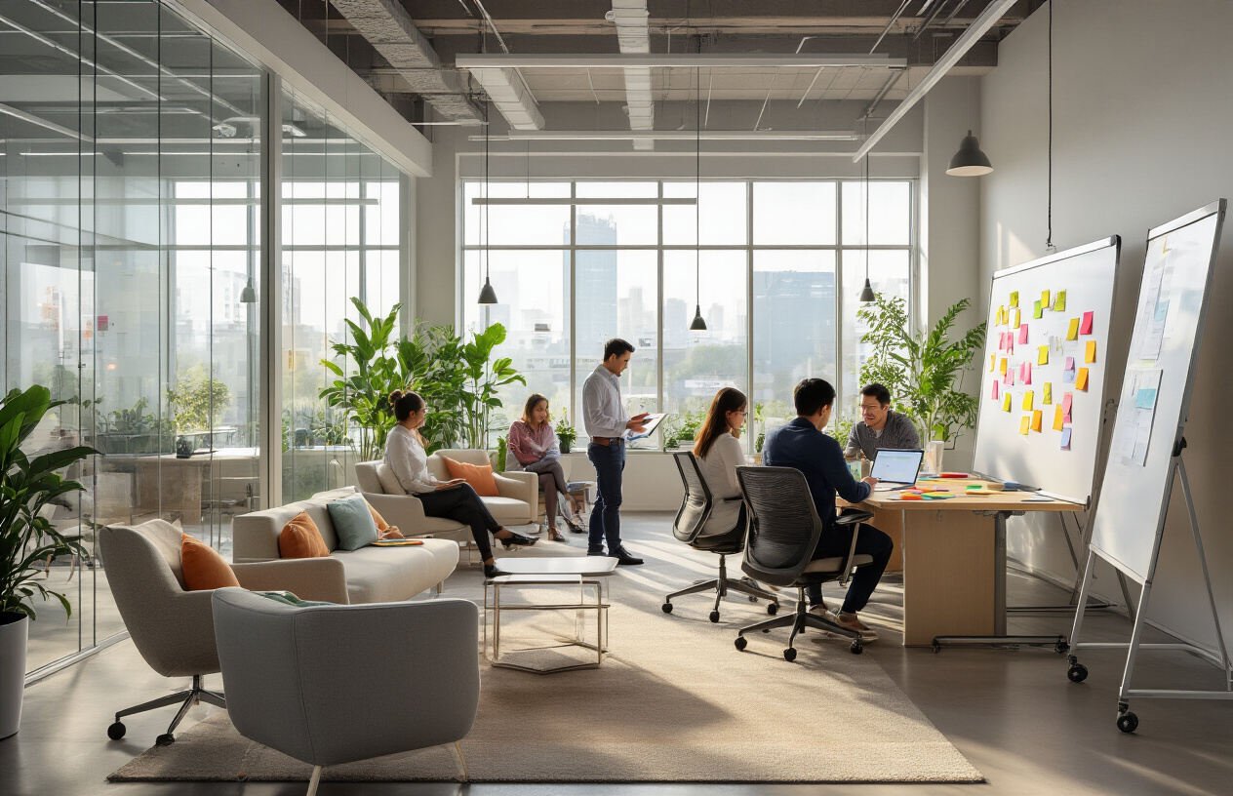

Design brainstorming areas with flexible furniture arrangements
Modern collaborative office spaces thrive on adaptability. Mobile whiteboards, lightweight tables on wheels, and modular seating systems transform any area into a dynamic brainstorming hub. Stack-able chairs and nesting tables store easily when not in use, maximizing your office space planning efficiency.
Consider investing in furniture pieces that serve multiple purposes. Ottoman storage units double as seating and supply containers, while height-adjustable tables accommodate both standing and sitting work sessions. This flexibility keeps creative energy flowing as teams can reconfigure spaces instantly based on project needs.

Establish quiet meeting spaces for focused discussions
Not every collaboration requires an open environment. Acoustic pods and semi-enclosed meeting nooks provide the perfect balance between accessibility and privacy. These spaces need sound-absorbing materials like fabric panels or acoustic foam to minimize distractions from the main workspace.
Glass partitions maintain visual connection while reducing noise transfer. Add comfortable seating for 4-6 people, integrated power outlets, and soft lighting to create an inviting atmosphere for deeper conversations. These quiet zones become essential for sensitive discussions and detailed project planning.

Build informal gathering spots that foster spontaneous conversations
Workplace design ideas should include casual meeting areas that feel more like living spaces than traditional offices. Think café-style seating, comfortable lounge chairs, and communal tables near coffee stations or kitchen areas. These informal spots encourage employees to step away from their desks and connect naturally.
Position these gathering areas strategically along high-traffic pathways where people naturally cross paths. Add plants, warm lighting, and comfortable temperature control to make these spaces genuinely appealing throughout the day.

Install writable surfaces throughout collaborative areas
Writable walls, glass boards, and magnetic surfaces turn every vertical space into a potential canvas for ideas. Paint entire walls with whiteboard coating or install large-scale writable glass panels that double as room dividers. These surfaces should be easily accessible and well-lit to encourage spontaneous note-taking and idea sharing.
Provide various writing tools in nearby storage solutions - different colored markers, sticky notes, and erasers. Consider digital writable surfaces for tech-forward teams who want to save and share their brainstorming sessions instantly.

Provide technology support for seamless team presentations
Collaborative office spaces need robust technology infrastructure. Install ceiling-mounted projectors or large wall-mounted displays in key areas. Wireless presentation systems let team members share screens from any device without fumbling with cables.
Ensure strong Wi-Fi coverage and plenty of power outlets throughout collaborative zones. USB charging stations built into furniture keep devices powered during long brainstorming sessions. Cable management systems keep the space tidy while providing easy access to connections when needed.
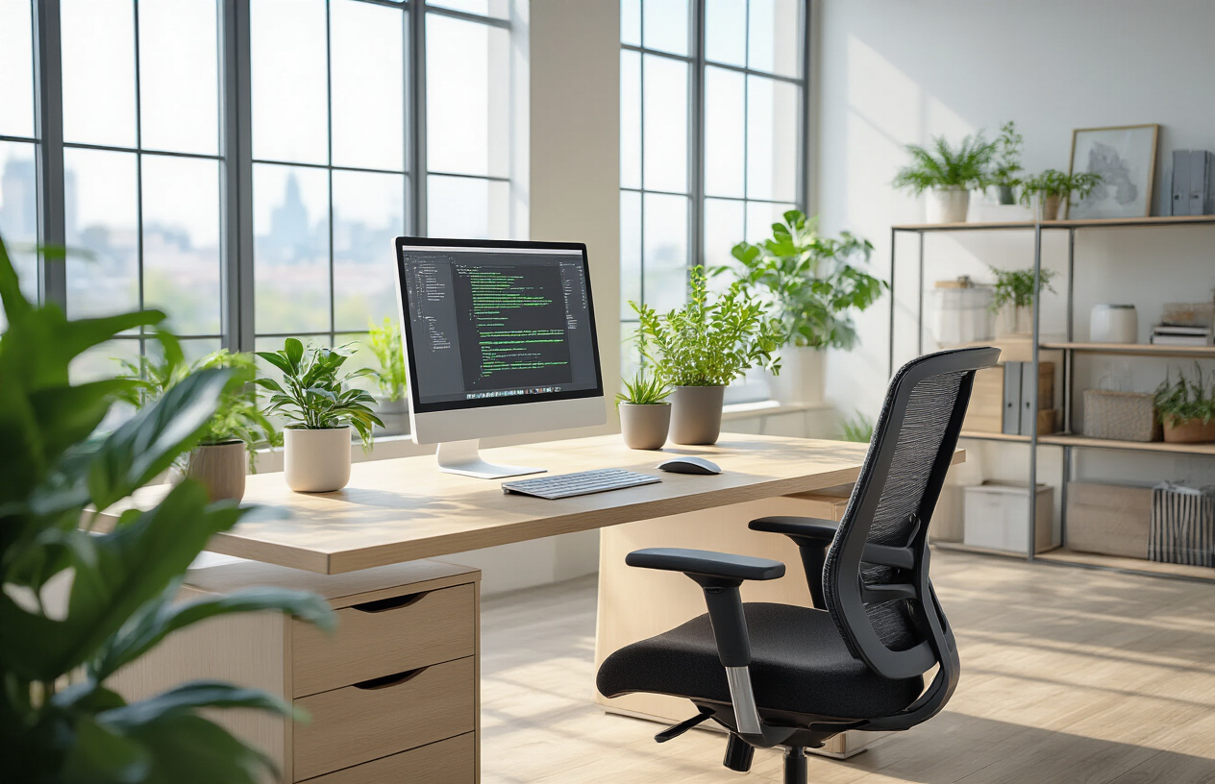
Creating an effective office workspace isn't just about picking nice furniture and calling it a day. Smart space planning, the right colors and materials, ergonomic solutions, and well-designed collaborative areas all work together to boost productivity and keep employees healthy and engaged. When you get these elements right, you're not just designing a place to work – you're creating an environment where people actually want to spend their time and do their best work.
The office spaces that really work are the ones that think about people first. Start with one or two key areas that need the most attention, whether that's better lighting, more comfortable seating, or a dedicated space for team brainstorming sessions. Small changes can make a big difference, and your team will notice when you invest in making their daily work experience better. Your office should work as hard as your people do.

